Prediction of nearest neighbor effects on backbone torsion angles and NMR scalar coupling constants in disordered proteins

Yang Shen,ª Julien Roche,^{a,b} Alexander Grishaev,^{a,c} Ad Baxª

ª Laboratory of Chemical Physics, National Institute of Diabetes and Digestive and Kidney Diseases, National Institutes of Health, Bethesda, MD 20892-0520, U.S.A.

^{b} Present address: Roy J. Carver Department of Biochemistry, Biophysics and Molecular Biology, Iowa State University, Ames, IA 50011, USA
^{c} National Institute of Standards and Technology and the Institute for Bioscience and Biotechnology Research, Rockville, Maryland 20850, United States

Supporting Information

Supplementary Table S1. Average difference between SPARTA+ predicted chemical shifts for various coil libraries and Poulsen random coil values.ª

 | <Δδ(¹³C^{α})> |  | <Δδ(¹³Cʹ)> |  | <Δδ(¹⁵N)>
 | RMSD ^{f} [ppm] | All ^{g}  [ppm] | RMSD ^{f} [ppm] | All ^{g}  [ppm] | RMSD ^{f} [ppm] | All ^{g}  [ppm]
δ^{RC}_{New}^{b} | 0.26 | 0.09 | 0.26 | 0.12 | 0.72 | 0.49
δ^{RC}_{MERA}^{c} | 0.26 | -0.13 | 0.24 | -0.14 | 1.11 | 0.93
δ^{RC}_{Fitzkee}^{d} | 0.34 | -0.30 | 0.35 | -0.27 | 1.04 | 0.80
δ^{RC}_{Coil-4}^{e} | 0.31 | -0.27 | 0.29 | -0.17 | 0.96 | 0.70
ª For each coil library residue, the difference between its SPARTA+ calculated ¹³C^{α}, ¹³C' and ¹⁵N chemical shifts (except δ¹⁵N for Pro) in the context of the X-ray coordinates from which the coil fragment was extracted, and its Poulsen random coil value¹ is used to derive the difference.
^{b} Newly derived coil library
^{c} MERA coil library.²
^{d} Fitzkee coil library.³
^{e} Coil-4 library.⁴
^{f} Root mean square value of the average difference between library-derived values using SPARTA+ and Poulsen random coil values for the 20 residue types
^{g} Average difference between the coil library derived chemical shifts and the Poulsen values

Supplementary Table S2. Effects of residue type and nearest neighbors on the backbone conformational distribution
 | d{X}ª |  |  |  |  |  | <$p\left\{Z−\underline{X}\right\}$/$p\left\{X−\underline{X}\right\}$> ^{b} |  |  |  | <$p\left\{\underline{X}−Z\right\}$/$p\left\{\underline{X}−X\right\}$> ^{b}
 | PPII | β | α_{R} | β-I | α_{L} | Other | PPII | β | α_{R} | β-I | PPII | β | α_{R} | β-I
A | 0.31 | 0.22 | 0.14 | 0.03 | 0.01 | 0.28 | 0.98 | 0.95 | 1.12 | 0.99 | 1.04 | 1.07 | 0.86 | 0.80
C | 0.21 | 0.38 | 0.08 | 0.05 | 0.01 | 0.28 | 0.75 | 0.69 | 1.29 | 2.33 | 0.96 | 0.97 | 0.87 | 0.93
D | 0.16 | 0.14 | 0.15 | 0.12 | 0.03 | 0.39 | 0.88 | 1.16 | 0.87 | 0.97 | 0.83 | 0.97 | 1.19 | 1.34
E | 0.27 | 0.28 | 0.14 | 0.04 | 0.01 | 0.26 | 1.17 | 1.03 | 0.74 | 0.59 | 0.91 | 0.99 | 1.27 | 0.90
F | 0.23 | 0.40 | 0.06 | 0.05 | 0.01 | 0.24 | 0.66 | 1.22 | 1.06 | 1.15 | 0.74 | 1.17 | 1.19 | 0.96
G | 0.07 | 0.07 | 0.04 | 0.02 | 0.04 | 0.76 | 0.98 | 0.86 | 1.05 | 1.54 | 0.90 | 0.90 | 0.91 | 1.71
H | 0.19 | 0.37 | 0.07 | 0.06 | 0.02 | 0.28 | 1.07 | 1.03 | 0.97 | 0.98 | 1.01 | 0.90 | 1.14 | 1.09
I | 0.24 | 0.47 | 0.07 | 0.03 | 0.00 | 0.19 | 0.98 | 1.00 | 0.92 | 1.03 | 1.10 | 1.06 | 0.76 | 0.68
K | 0.23 | 0.28 | 0.14 | 0.05 | 0.01 | 0.28 | 1.19 | 1.06 | 0.72 | 0.66 | 1.14 | 0.97 | 1.04 | 0.74
L | 0.31 | 0.31 | 0.11 | 0.05 | 0.00 | 0.22 | 0.79 | 1.04 | 1.29 | 1.02 | 1.17 | 1.11 | 0.65 | 0.62
M | 0.24 | 0.34 | 0.09 | 0.05 | 0.01 | 0.26 | 1.03 | 0.93 | 1.10 | 0.93 | 1.13 | 0.93 | 0.92 | 0.92
N | 0.13 | 0.18 | 0.10 | 0.11 | 0.06 | 0.42 | 0.97 | 1.09 | 0.91 | 0.94 | 0.83 | 1.01 | 1.26 | 1.16
P | 0.58 | 0.06 | 0.12 | 0.02 | 0.00 | 0.23 | 1.15 | 0.86 | 1.28 | 0.90 | 1.61 | 1.43 | - | -
Q | 0.23 | 0.33 | 0.11 | 0.05 | 0.01 | 0.26 | 1.18 | 0.95 | 0.93 | 0.67 | 1.05 | 0.95 | 1.06 | 1.01
R | 0.21 | 0.35 | 0.10 | 0.05 | 0.01 | 0.28 | 1.11 | 0.95 | 0.97 | 1.04 | 1.14 | 0.91 | 1.22 | 0.83
S | 0.19 | 0.27 | 0.15 | 0.07 | 0.01 | 0.30 | 0.93 | 0.99 | 1.05 | 1.00 | 0.96 | 1.02 | 1.03 | 1.08
T | 0.17 | 0.31 | 0.12 | 0.12 | 0.00 | 0.28 | 0.99 | 1.09 | 0.85 | 1.04 | 1.16 | 0.96 | 0.87 | 1.00
V | 0.22 | 0.50 | 0.06 | 0.03 | 0.00 | 0.19 | 1.12 | 0.98 | 0.81 | 0.99 | 1.23 | 0.96 | 0.80 | 0.73
W | 0.23 | 0.29 | 0.15 | 0.07 | 0.01 | 0.25 | 0.59 | 1.21 | 1.35 | 1.10 | 0.79 | 1.14 | 0.94 | 0.88
Y | 0.23 | 0.40 | 0.08 | 0.05 | 0.01 | 0.24 | 0.68 | 1.28 | 0.93 | 1.08 | 0.72 | 1.13 | 1.14 | 1.04

ª For each residue type X in the coil database, the population in a given φ/ψ region r, d(X,r), is calculated as the ratio of the residue density d in a given region r, Σd(φ,ψ)^{r}/Σd(φ,ψ). Ramachandran space is divided into six regions, comprising r = PPII, β, α_{R}, type I β-turn (β-I), α_{R}, and all other (for definitions see legend to Fig. 1).
^{b} Analogous to Table1 (b), the ratio of the ANN predicted 6-region probability p_{i} (Eq. 1) between the residue X in subsets $\left\{Z−X\right\}$ ($\left\{X−Z\right\}$) and $\left\{X−\underline{X}\right\}$ ($\left\{\underline{X}−X\right\}$) of the coil library are calculated and listed for four regions: PPII, β, α_{R} and β-I and for each residue type Z. Gly, Pro and Xaa-Pro are excluded from center residues X. Ratios with uncertainty larger than 0.03 [see Table S3] are boldfaced.
Supplementary Table S3. Uncertainties of the analysis of the nearest-neighbor effects on the backbone conformational distribution
Z | σ($d\left\{Z−\underline{X}\right\}$/$d\left\{X−\underline{X}\right\}$) ª |  |  |  | σ($p\left\{Z−\underline{X}\right\}$/$p\left\{X−\underline{X}\right\}$) ^{b} |  |  |  | σ($d\left\{\underline{X}−Z\right\}$/$d\left\{\underline{X}−X\right\}$) ª |  |  |  | σ($p\left\{\underline{X}−Z\right\}$/$p\left\{\underline{X}−X\right\}$) ^{b}
Z | PPII | β | α_{R} | β-I | PPII | β | α_{R} | β-I | PPII | β | α_{R} | β-I | PPII | β | α_{R} | β-I
A | 0.01 | 0.01 | 0.02 | 0.02 | 0.01 | 0.02 | 0.02 | 0.01 | 0.01 | 0.01 | 0.03 | 0.03 | 0.01 | 0.02 | 0.01 | 0.01
C | 0.02 | 0.05 | 0.05 | 0.12 | 0.03 | 0.03 | 0.04 | 0.05 | 0.02 | 0.03 | 0.03 | 0.06 | 0.02 | 0.03 | 0.02 | 0.02
D | 0.01 | 0.03 | 0.03 | 0.03 | 0.01 | 0.02 | 0.02 | 0.01 | 0.01 | 0.01 | 0.02 | 0.02 | 0.01 | 0.02 | 0.01 | 0.02
E | 0.02 | 0.02 | 0.01 | 0.02 | 0.01 | 0.01 | 0.01 | 0.01 | 0.02 | 0.01 | 0.03 | 0.03 | 0.02 | 0.02 | 0.02 | 0.01
F | 0.02 | 0.03 | 0.05 | 0.05 | 0.02 | 0.02 | 0.02 | 0.02 | 0.02 | 0.02 | 0.03 | 0.04 | 0.02 | 0.02 | 0.02 | 0.01
G | 0.01 | 0.01 | 0.02 | 0.02 | 0.01 | 0.01 | 0.02 | 0.01 | 0.01 | 0.02 | 0.03 | 0.05 | 0.01 | 0.01 | 0.01 | 0.02
H | 0.01 | 0.02 | 0.04 | 0.03 | 0.02 | 0.02 | 0.03 | 0.02 | 0.01 | 0.02 | 0.03 | 0.06 | 0.02 | 0.02 | 0.03 | 0.02
I | 0.04 | 0.03 | 0.03 | 0.09 | 0.01 | 0.02 | 0.02 | 0.01 | 0.02 | 0.02 | 0.04 | 0.05 | 0.01 | 0.02 | 0.01 | 0.01
K | 0.02 | 0.02 | 0.02 | 0.03 | 0.01 | 0.02 | 0.01 | 0.01 | 0.02 | 0.01 | 0.02 | 0.03 | 0.02 | 0.02 | 0.02 | 0.01
L | 0.01 | 0.03 | 0.05 | 0.04 | 0.01 | 0.02 | 0.02 | 0.01 | 0.03 | 0.01 | 0.03 | 0.01 | 0.02 | 0.02 | 0.02 | 0.01
M | 0.03 | 0.03 | 0.05 | 0.05 | 0.02 | 0.03 | 0.03 | 0.03 | 0.04 | 0.03 | 0.03 | 0.07 | 0.02 | 0.03 | 0.03 | 0.03
N | 0.01 | 0.01 | 0.03 | 0.02 | 0.01 | 0.02 | 0.01 | 0.01 | 0.02 | 0.03 | 0.03 | 0.03 | 0.01 | 0.02 | 0.02 | 0.02
P | 0.01 | 0.01 | 0.02 | 0.01 | 0.01 | 0.02 | 0.01 | 0.01 | 0.12 | 0.09 | 0.00 | 0.00 | 0.02 | 0.02 | 0.01 | 0.00
Q | 0.03 | 0.02 | 0.04 | 0.05 | 0.01 | 0.02 | 0.01 | 0.01 | 0.02 | 0.02 | 0.02 | 0.04 | 0.02 | 0.02 | 0.02 | 0.02
R | 0.03 | 0.01 | 0.03 | 0.03 | 0.02 | 0.02 | 0.02 | 0.02 | 0.03 | 0.02 | 0.04 | 0.02 | 0.02 | 0.02 | 0.02 | 0.01
S | 0.02 | 0.01 | 0.02 | 0.02 | 0.01 | 0.01 | 0.02 | 0.01 | 0.01 | 0.01 | 0.03 | 0.04 | 0.01 | 0.02 | 0.02 | 0.01
T | 0.02 | 0.02 | 0.03 | 0.03 | 0.01 | 0.02 | 0.01 | 0.01 | 0.02 | 0.01 | 0.02 | 0.03 | 0.01 | 0.01 | 0.01 | 0.01
V | 0.01 | 0.02 | 0.02 | 0.05 | 0.02 | 0.02 | 0.02 | 0.01 | 0.01 | 0.02 | 0.03 | 0.02 | 0.02 | 0.02 | 0.02 | 0.01
W | 0.03 | 0.06 | 0.03 | 0.05 | 0.03 | 0.04 | 0.05 | 0.03 | 0.04 | 0.03 | 0.05 | 0.04 | 0.03 | 0.03 | 0.03 | 0.03
Y | 0.02 | 0.02 | 0.05 | 0.05 | 0.02 | 0.02 | 0.02 | 0.02 | 0.01 | 0.02 | 0.04 | 0.07 | 0.02 | 0.02 | 0.03 | 0.02
ª Uncertainties in the values of Table 1, main text, derived from jackknifing.
^{b} Uncertainties in the probability ratios of Table S2.
Supplementary Table S4. Nearest-neighbor effects from charged amino acids on the backbone conformational distribution ª
 | P(PPII) | P(β) | P(α_{R}) | P(β-I) | P(α_{L}) | P(Other)
{DE}-X-{DE} | 0.210 | 0.368 | 0.103 | 0.040 | 0.014 | 0.264
{DE}-X-{KR} | 0.255 | 0.332 | 0.083 | 0.035 | 0.009 | 0.285
{DE}-X-X | 0.226 | 0.335 | 0.093 | 0.053 | 0.016 | 0.277
{KR}-X-{DE} | 0.217 | 0.320 | 0.119 | 0.070 | 0.010 | 0.264
{KR}-X-{KR} | 0.281 | 0.333 | 0.085 | 0.036 | 0.018 | 0.248
{KR}-X-X | 0.258 | 0.317 | 0.089 | 0.051 | 0.016 | 0.269
{DE}-{DE}-X | 0.223 | 0.242 | 0.109 | 0.067 | 0.024 | 0.335
{KR}-{DE}-X | 0.267 | 0.221 | 0.117 | 0.062 | 0.025 | 0.307
X-{DE}-X | 0.217 | 0.214 | 0.147 | 0.082 | 0.017 | 0.323
{DE}-{KR}-X | 0.220 | 0.340 | 0.096 | 0.044 | 0.013 | 0.285
{KR}-{KR}-X | 0.276 | 0.319 | 0.093 | 0.038 | 0.012 | 0.262
X-{KR}-X | 0.227 | 0.309 | 0.125 | 0.051 | 0.009 | 0.279
X-{DE}-{DE} | 0.182 | 0.184 | 0.206 | 0.085 | 0.011 | 0.332
X-{DE}-{KR} | 0.202 | 0.188 | 0.198 | 0.087 | 0.014 | 0.311
X-{DE}-X | 0.217 | 0.214 | 0.147 | 0.082 | 0.017 | 0.323
X-{KR}-{DE} | 0.164 | 0.262 | 0.191 | 0.060 | 0.009 | 0.315
X-{KR}-{KR} | 0.258 | 0.267 | 0.142 | 0.045 | 0.007 | 0.281
X-{KR}-X | 0.227 | 0.309 | 0.125 | 0.051 | 0.009 | 0.279
X-X-{DE} | 0.195 | 0.301 | 0.140 | 0.072 | 0.008 | 0.284
X-X-{KR} | 0.255 | 0.298 | 0.122 | 0.052 | 0.010 | 0.264
ª For residues with positive charge {KR} and negative charge {DE}, the impacts on the backbone φ/ψ torsion angle distribution of their nearest neighbor, X, is evaluated for the six Ramachandran regions: PPII, β, α_{R}, type I β-turn (β-I), α_{L}, and “other”. Triplets are grouped according to charge. X stands for the collection of all residue types except Gly, Pro, Xaa-Pro when X is the center residue, and not Pro when X is the last residue of the triplet.. Probability P(r) for the center residue to reside in region r is calculated as Σd(φ,ψ)^{r}/Σd(φ,ψ), where Σd(φ,ψ)_{r} is the observed residue density in region r and Σd(φ,ψ) is the total residue density.

Supplementary Table S5. Average ³J_{HN-Hα} coupling constants for residues in coil conformation
X | <³J(X)>ª  [Hz] | <³J(X)>_{ANN}^{b}  [Hz] | <³J(X)^{Smith}>^{c}  [Hz] | <³J(X)^{Serrano}>^{d}  [Hz] | <³J(X)^{GGXGG}>^{e}  [Hz]
A | 5.81 | 5.83 | 5.8 | 5.67 | 5.73
C | 7.02 | 7.15 | 6.8 | 7.10 | 7.60
D | 6.89 | 6.98 | 6.6 | 6.60 | 7.50
E | 6.55 | 6.57 | 6.2 | 6.07 | 6.78
F | 7.23 | 7.11 | 7.1 | 7.06 | 6.97
H | 7.24 | 7.34 | 6.9 | 7.05 | 7.80
I | 7.60 | 7.26 | 7.2 | 7.24 | 7.52
K | 6.70 | 6.71 | 6.6 | 6.41 | 7.10
L | 6.86 | 6.89 | 6.6 | 6.58 | 7.15
M | 6.88 | 6.94 | 6.8 | 6.52 | 7.70
N | 7.33 | 7.32 | 7.0 | 7.04 | 7.57
Q | 6.99 | 6.73 | 6.3 | 6.39 | 7.30
R | 6.96 | 6.66 | 6.4 | 6.46 | 7.20
S | 6.83 | 6.40 | 6.6 | 6.61 | 6.30
T | 7.59 | 7.22 | 7.5 | 7.46 | 7.65
V | 7.73 | 7.16 | 7.3 | 7.44 | 7.05
W | 6.81 | 6.44 | 6.5 | 6.70 | 6.50
Y | 7.17 | 6.74 | 7.2 | 7.18 | 6.91
ª Average ³J_{HN-Hα} coupling constants calculated from Eq 2.
^{b} Calculated average ³J_{HN-Hα} coupling constant A_{X} in Eq 4.
^{c} from Smith et al. ⁵
^{d} from Serrano⁶.
^{e} from Shi et al.⁷

Supplementary Table S6. Standard deviation from the mean experimental ³J_{HN-Hα} couplings observed in triplets of identical residue composition in our set of disordered peptides and proteins.
Tri-peptide | Number | <³J_{HNHα}>  [Hz] | Std.dev  [Hz]
AAA | 2 | 5.40 | 0.17
AEK | 2 | 6.06 | 0.02
AKI | 2 | 6.31 | 0.19
AVV | 2 | 7.34 | 0.12
EEG | 2 | 6.25 | 0.06
EKT | 2 | 6.39 | 0.04
FVK | 2 | 7.20 | 0.80
GAG | 2 | 5.67 | 0.07
GAV | 2 | 5.78 | 0.08
GIG | 2 | 7.46 | 0.06
GKT | 2 | 6.93 | 0.08
GVA | 2 | 7.34 | 0.28
IIG | 2 | 7.46 | 0.30
IKV | 2 | 6.98 | 0.01
IQD | 2 | 6.85 | 0.15
ITL | 2 | 7.98 | 0.02
LED | 2 | 6.90 | 0.31
LWK | 2 | 6.38 | 0.16
VAE | 2 | 5.53 | 0.01
WKG | 2 | 7.69 | 0.37
GVV | 3 | 7.72 | 0.49
KAK | 3 | 5.30 | 0.07
TKE | 3 | 6.46 | 0.08
KEG | 4 | 6.37 | 0.43
KTK | 4 | 6.99 | 0.17

Supplementary Table S7. Pairwise Hellinger distances (scaled by 100) for 20 residues calculated from their backbone φ/ψ distribution observed in the coil library.
X_{i} | A | C | D | E | F | G | H | I | K | L | M | N | P | Q | R | S | T | V | W | Y
A | 0.0 | 21.4 | 26.1 | 11.5 | 21.0 | 57.2 | 21.3 | 30.1 | 14.4 | 19.0 | 17.3 | 31.8 | 38.2 | 16.2 | 16.0 | 17.1 | 26.6 | 30.0 | 17.2 | 19.6
C | 21.4 | 0.0 | 28.6 | 18.7 | 10.3 | 58.6 | 11.0 | 23.9 | 17.8 | 22.4 | 14.6 | 28.5 | 53.9 | 14.7 | 12.8 | 18.4 | 23.0 | 22.4 | 17.1 | 12.2
D | 26.1 | 28.6 | 0.0 | 24.0 | 29.5 | 53.6 | 26.2 | 38.7 | 22.5 | 28.2 | 24.5 | 13.3 | 49.5 | 24.4 | 25.1 | 22.0 | 26.9 | 38.6 | 24.6 | 29.5
E | 11.5 | 18.7 | 24.0 | 0.0 | 17.1 | 58.2 | 17.9 | 22.5 | 6.5 | 11.7 | 12.1 | 29.1 | 43.3 | 8.8 | 11.3 | 14.3 | 20.3 | 22.6 | 12.9 | 14.2
F | 21.0 | 10.3 | 29.5 | 17.1 | 0.0 | 59.7 | 10.4 | 20.9 | 16.5 | 20.0 | 12.8 | 29.3 | 53.4 | 12.2 | 10.3 | 19.0 | 21.1 | 18.6 | 16.5 | 7.8
G | 57.2 | 58.6 | 53.6 | 58.2 | 59.7 | 0.0 | 56.0 | 68.3 | 57.6 | 61.8 | 58.0 | 53.1 | 72.6 | 57.6 | 57.3 | 53.9 | 61.3 | 66.6 | 60.8 | 59.5
H | 21.3 | 11.0 | 26.2 | 17.9 | 10.4 | 56.0 | 0.0 | 25.4 | 17.0 | 22.8 | 12.7 | 24.6 | 54.5 | 13.8 | 10.4 | 17.0 | 22.5 | 23.2 | 17.8 | 11.5
I | 30.1 | 23.9 | 38.7 | 22.5 | 20.9 | 68.3 | 25.4 | 0.0 | 21.9 | 18.2 | 21.4 | 40.3 | 54.5 | 20.2 | 22.3 | 29.7 | 25.3 | 6.8 | 24.7 | 18.8
K | 14.4 | 17.8 | 22.5 | 6.5 | 16.5 | 57.6 | 17.0 | 21.9 | 0.0 | 13.2 | 11.1 | 27.5 | 46.5 | 8.4 | 10.4 | 12.8 | 17.5 | 21.8 | 12.0 | 13.7
L | 19.0 | 22.4 | 28.2 | 11.7 | 20.0 | 61.8 | 22.8 | 18.2 | 13.2 | 0.0 | 14.9 | 32.8 | 42.2 | 13.3 | 17.7 | 21.6 | 21.8 | 19.3 | 16.7 | 17.4
M | 17.3 | 14.6 | 24.5 | 12.1 | 12.8 | 58.0 | 12.7 | 21.4 | 11.1 | 14.9 | 0.0 | 26.6 | 48.1 | 10.0 | 10.5 | 15.6 | 19.2 | 20.5 | 12.7 | 11.5
N | 31.8 | 28.5 | 13.3 | 29.1 | 29.3 | 53.1 | 24.6 | 40.3 | 27.5 | 32.8 | 26.6 | 0.0 | 56.8 | 27.7 | 27.3 | 27.5 | 31.8 | 39.5 | 29.4 | 30.6
P | 38.2 | 53.9 | 49.5 | 43.3 | 53.4 | 72.6 | 54.5 | 54.5 | 46.5 | 42.2 | 48.1 | 56.8 | 0.0 | 48.4 | 50.3 | 48.8 | 52.7 | 56.1 | 46.0 | 51.9
Q | 16.2 | 14.7 | 24.4 | 8.8 | 12.2 | 57.6 | 13.8 | 20.2 | 8.4 | 13.3 | 10.0 | 27.7 | 48.4 | 0.0 | 7.9 | 13.8 | 17.2 | 18.8 | 13.1 | 10.2
R | 16.0 | 12.8 | 25.1 | 11.3 | 10.3 | 57.3 | 10.4 | 22.3 | 10.4 | 17.7 | 10.5 | 27.3 | 50.3 | 7.9 | 0.0 | 12.6 | 18.2 | 20.6 | 13.8 | 8.9
S | 17.1 | 18.4 | 22.0 | 14.3 | 19.0 | 53.9 | 17.0 | 29.7 | 12.8 | 21.6 | 15.6 | 27.5 | 48.8 | 13.8 | 12.6 | 0.0 | 16.0 | 28.3 | 13.7 | 17.3
T | 26.6 | 23.0 | 26.9 | 20.3 | 21.1 | 61.3 | 22.5 | 25.3 | 17.5 | 21.8 | 19.2 | 31.8 | 52.7 | 17.2 | 18.2 | 16.0 | 0.0 | 23.9 | 16.9 | 19.8
V | 30.0 | 22.4 | 38.6 | 22.6 | 18.6 | 66.6 | 23.2 | 6.8 | 21.8 | 19.3 | 20.5 | 39.5 | 56.1 | 18.8 | 20.6 | 28.3 | 23.9 | 0.0 | 24.7 | 16.8
W | 17.2 | 17.1 | 24.6 | 12.9 | 16.5 | 60.8 | 17.8 | 24.7 | 12.0 | 16.7 | 12.7 | 29.4 | 46.0 | 13.1 | 13.8 | 13.7 | 16.9 | 24.7 | 0.0 | 14.9
Y | 19.6 | 12.2 | 29.5 | 14.2 | 7.8 | 59.5 | 11.5 | 18.8 | 13.7 | 17.4 | 11.5 | 30.6 | 51.9 | 10.2 | 8.9 | 17.3 | 19.8 | 16.8 | 14.9 | 0.0
Present as left neighbor
U_{i}-X | A | C | D | E | F | G | H | I | K | L | M | N | P | Q | R | S | T | V | W | Y
A | 0.0 | 17.1 | 10.4 | 10.1 | 12.5 | 8.6 | 9.6 | 11.0 | 10.0 | 9.0 | 9.5 | 9.6 | 7.9 | 9.3 | 6.9 | 7.0 | 7.8 | 10.4 | 14.6 | 12.5
C | 17.1 | 0.0 | 18.9 | 22.2 | 18.6 | 14.4 | 18.5 | 19.2 | 22.3 | 15.4 | 19.5 | 18.4 | 16.9 | 21.2 | 18.0 | 16.7 | 17.7 | 19.8 | 16.9 | 19.4
D | 10.4 | 18.9 | 0.0 | 11.4 | 13.9 | 11.2 | 10.2 | 15.9 | 10.6 | 13.3 | 13.1 | 6.8 | 12.2 | 13.2 | 10.1 | 7.4 | 7.4 | 15.0 | 15.0 | 11.7
E | 10.1 | 22.2 | 11.4 | 0.0 | 15.5 | 14.0 | 10.3 | 12.4 | 5.9 | 13.7 | 12.2 | 10.6 | 10.4 | 8.2 | 8.4 | 11.0 | 9.0 | 10.3 | 18.0 | 14.4
F | 12.5 | 18.6 | 13.9 | 15.5 | 0.0 | 13.8 | 13.9 | 13.3 | 16.1 | 8.8 | 14.8 | 14.1 | 13.9 | 16.2 | 13.9 | 13.2 | 12.0 | 13.4 | 11.5 | 8.4
G | 8.6 | 14.4 | 11.2 | 14.0 | 13.8 | 0.0 | 11.2 | 13.9 | 13.4 | 11.5 | 11.0 | 9.8 | 10.2 | 12.5 | 9.4 | 8.3 | 9.0 | 12.8 | 15.7 | 14.0
H | 9.6 | 18.5 | 10.2 | 10.3 | 13.9 | 11.2 | 0.0 | 12.7 | 9.2 | 12.0 | 11.7 | 9.7 | 8.6 | 10.7 | 8.0 | 8.7 | 8.1 | 11.6 | 15.5 | 12.9
I | 11.0 | 19.2 | 15.9 | 12.4 | 13.3 | 13.9 | 12.7 | 0.0 | 12.9 | 10.8 | 13.0 | 15.6 | 11.4 | 12.4 | 10.6 | 13.9 | 12.1 | 7.3 | 15.4 | 13.6
K | 10.0 | 22.3 | 10.6 | 5.9 | 16.1 | 13.4 | 9.2 | 12.9 | 0.0 | 14.2 | 10.7 | 10.2 | 10.8 | 8.4 | 7.8 | 10.4 | 8.6 | 11.0 | 18.5 | 14.8
L | 9.0 | 15.4 | 13.3 | 13.7 | 8.8 | 11.5 | 12.0 | 10.8 | 14.2 | 0.0 | 12.2 | 12.7 | 10.0 | 13.4 | 10.6 | 10.5 | 10.4 | 11.1 | 11.4 | 10.4
M | 9.5 | 19.5 | 13.1 | 12.2 | 14.8 | 11.0 | 11.7 | 13.0 | 10.7 | 12.2 | 0.0 | 11.8 | 10.6 | 10.3 | 9.3 | 10.6 | 10.4 | 11.8 | 16.8 | 13.9
N | 9.6 | 18.4 | 6.8 | 10.6 | 14.1 | 9.8 | 9.7 | 15.6 | 10.2 | 12.7 | 11.8 | 0.0 | 10.5 | 11.1 | 8.8 | 6.3 | 6.9 | 14.4 | 15.9 | 13.3
P | 7.9 | 16.9 | 12.2 | 10.4 | 13.9 | 10.2 | 8.6 | 11.4 | 10.8 | 10.0 | 10.6 | 10.5 | 0.0 | 9.5 | 7.4 | 9.2 | 9.5 | 10.4 | 15.2 | 13.8
Q | 9.3 | 21.2 | 13.2 | 8.2 | 16.2 | 12.5 | 10.7 | 12.4 | 8.4 | 13.4 | 10.3 | 11.1 | 9.5 | 0.0 | 8.3 | 10.7 | 9.7 | 10.7 | 18.8 | 16.0
R | 6.9 | 18.0 | 10.1 | 8.4 | 13.9 | 9.4 | 8.0 | 10.6 | 7.8 | 10.6 | 9.3 | 8.8 | 7.4 | 8.3 | 0.0 | 7.9 | 7.4 | 9.9 | 15.4 | 13.3
S | 7.0 | 16.7 | 7.4 | 11.0 | 13.2 | 8.3 | 8.7 | 13.9 | 10.4 | 10.5 | 10.6 | 6.3 | 9.2 | 10.7 | 7.9 | 0.0 | 6.6 | 13.1 | 14.8 | 12.5
T | 7.8 | 17.7 | 7.4 | 9.0 | 12.0 | 9.0 | 8.1 | 12.1 | 8.6 | 10.4 | 10.4 | 6.9 | 9.5 | 9.7 | 7.4 | 6.6 | 0.0 | 10.4 | 14.3 | 11.1
V | 10.4 | 19.8 | 15.0 | 10.3 | 13.4 | 12.8 | 11.6 | 7.3 | 11.0 | 11.1 | 11.8 | 14.4 | 10.4 | 10.7 | 9.9 | 13.1 | 10.4 | 0.0 | 17.0 | 13.6
W | 14.6 | 16.9 | 15.0 | 18.0 | 11.5 | 15.7 | 15.5 | 15.4 | 18.5 | 11.4 | 16.8 | 15.9 | 15.2 | 18.8 | 15.4 | 14.8 | 14.3 | 17.0 | 0.0 | 10.3
Y | 12.5 | 19.4 | 11.7 | 14.4 | 8.4 | 14.0 | 12.9 | 13.6 | 14.8 | 10.4 | 13.9 | 13.3 | 13.8 | 16.0 | 13.3 | 12.5 | 11.1 | 13.6 | 10.3 | 0.0
Present as right neighbor
X-U_{i} | A | C | D | E | F | G | H | I | K | L | M | N | P | Q | R | S | T | V | W | Y
A | 0.0 | 10.6 | 9.2 | 9.3 | 9.9 | 11.0 | 9.2 | 11.7 | 7.3 | 10.5 | 9.5 | 8.5 | 34.0 | 7.2 | 8.5 | 7.0 | 7.6 | 10.7 | 13.5 | 10.6
C | 10.6 | 0.0 | 13.2 | 14.5 | 12.8 | 13.6 | 13.3 | 13.8 | 13.1 | 12.2 | 13.9 | 12.9 | 36.0 | 11.8 | 12.1 | 11.6 | 11.7 | 13.0 | 14.2 | 13.6
D | 9.2 | 13.2 | 0.0 | 6.7 | 9.7 | 8.5 | 8.7 | 15.6 | 10.0 | 16.0 | 11.9 | 5.3 | 40.3 | 9.0 | 9.9 | 6.0 | 9.1 | 14.9 | 13.6 | 9.1
E | 9.3 | 14.5 | 6.7 | 0.0 | 11.1 | 10.5 | 8.1 | 16.2 | 8.1 | 16.2 | 11.3 | 5.4 | 39.8 | 8.6 | 8.4 | 6.6 | 9.9 | 14.6 | 15.4 | 10.5
F | 9.9 | 12.8 | 9.7 | 11.1 | 0.0 | 13.2 | 11.0 | 13.4 | 11.9 | 13.2 | 13.6 | 9.4 | 38.3 | 11.1 | 11.7 | 10.1 | 11.3 | 13.3 | 12.4 | 7.1
G | 11.0 | 13.6 | 8.5 | 10.5 | 13.2 | 0.0 | 10.6 | 18.2 | 12.8 | 18.0 | 13.8 | 9.3 | 40.5 | 11.3 | 13.2 | 7.9 | 11.0 | 17.6 | 15.4 | 13.5
H | 9.2 | 13.3 | 8.7 | 8.1 | 11.0 | 10.6 | 0.0 | 14.3 | 8.4 | 14.6 | 12.0 | 8.2 | 38.5 | 9.9 | 8.8 | 7.7 | 8.5 | 12.9 | 15.2 | 10.3
I | 11.7 | 13.8 | 15.6 | 16.2 | 13.4 | 18.2 | 14.3 | 0.0 | 12.1 | 7.7 | 11.8 | 14.9 | 32.5 | 12.5 | 12.3 | 14.5 | 10.2 | 6.5 | 14.0 | 13.8
K | 7.3 | 13.1 | 10.0 | 8.1 | 11.9 | 12.8 | 8.4 | 12.1 | 0.0 | 12.2 | 9.4 | 8.6 | 35.0 | 7.7 | 6.8 | 8.2 | 7.3 | 10.2 | 15.8 | 12.1
L | 10.5 | 12.2 | 16.0 | 16.2 | 13.2 | 18.0 | 14.6 | 7.7 | 12.2 | 0.0 | 11.7 | 15.3 | 30.7 | 11.7 | 12.1 | 14.3 | 11.2 | 7.0 | 14.3 | 14.3
M | 9.5 | 13.9 | 11.9 | 11.3 | 13.6 | 13.8 | 12.0 | 11.8 | 9.4 | 11.7 | 0.0 | 11.0 | 35.8 | 8.0 | 9.7 | 11.0 | 8.9 | 10.7 | 15.9 | 13.8
N | 8.5 | 12.9 | 5.3 | 5.4 | 9.4 | 9.3 | 8.2 | 14.9 | 8.6 | 15.3 | 11.0 | 0.0 | 39.6 | 8.6 | 8.9 | 6.2 | 8.8 | 14.0 | 14.2 | 9.4
P | 34.0 | 36.0 | 40.3 | 39.8 | 38.3 | 40.5 | 38.5 | 32.5 | 35.0 | 30.7 | 35.8 | 39.6 | 0.0 | 36.5 | 36.3 | 37.5 | 34.8 | 33.0 | 37.5 | 39.3
Q | 7.2 | 11.8 | 9.0 | 8.6 | 11.1 | 11.3 | 9.9 | 12.5 | 7.7 | 11.7 | 8.0 | 8.6 | 36.5 | 0.0 | 7.2 | 7.7 | 7.6 | 10.9 | 14.9 | 11.6
R | 8.5 | 12.1 | 9.9 | 8.4 | 11.7 | 13.2 | 8.8 | 12.3 | 6.8 | 12.1 | 9.7 | 8.9 | 36.3 | 7.2 | 0.0 | 8.7 | 7.5 | 10.1 | 14.7 | 12.0
S | 7.0 | 11.6 | 6.0 | 6.6 | 10.1 | 7.9 | 7.7 | 14.5 | 8.2 | 14.3 | 11.0 | 6.2 | 37.5 | 7.7 | 8.7 | 0.0 | 7.4 | 13.4 | 13.7 | 10.3
T | 7.6 | 11.7 | 9.1 | 9.9 | 11.3 | 11.0 | 8.5 | 10.2 | 7.3 | 11.2 | 8.9 | 8.8 | 34.8 | 7.6 | 7.5 | 7.4 | 0.0 | 9.1 | 13.4 | 11.1
V | 10.7 | 13.0 | 14.9 | 14.6 | 13.3 | 17.6 | 12.9 | 6.5 | 10.2 | 7.0 | 10.7 | 14.0 | 33.0 | 10.9 | 10.1 | 13.4 | 9.1 | 0.0 | 14.6 | 13.7
W | 13.5 | 14.2 | 13.6 | 15.4 | 12.4 | 15.4 | 15.2 | 14.0 | 15.8 | 14.3 | 15.9 | 14.2 | 37.5 | 14.9 | 14.7 | 13.7 | 13.4 | 14.6 | 0.0 | 11.9
Y | 10.6 | 13.6 | 9.1 | 10.5 | 7.1 | 13.5 | 10.3 | 13.8 | 12.1 | 14.3 | 13.8 | 9.4 | 39.3 | 11.6 | 12.0 | 10.3 | 11.1 | 13.7 | 11.9 | 0.0

Supplementary Table S8. Experimental ³J_{HN-Hα} couplings for pressure-unfolded HIV-1 Protease and DNA-binding domain of HIV-1 Integrase.ª
Integrase |  |  | Protease
Residue  Number | Residue  Type | ³J_{HN-Hα} [Hz] | Residue  Number | Residue  Type | ³J_{HN-Hα} [Hz] | Residue  Number | Residue  Type | ³J_{HN-Hα} [Hz]
3 | G | 5.69 | 3 | V | 7.41 | 62 | I | 6.73
4 | M | 6.64 | 4 | T | 7.76 | 66 | I | 7.73
5 | I | 7.15 | 5 | L | 7.09 | 69 | H | 7.65
6 | Q | 6.76 | 6 | W | 6.34 | 70 | K | 6.73
7 | N | 7.26 | 7 | K | 7.83 | 71 | A | 5.79
8 | F | 6.59 | 8 | R | 5.75 | 72 | I | 7.4
9 | R | 6.64 | 10 | L | 6.31 | 73 | G | 5.87
10 | V | 7.49 | 11 | V | 7.99 | 74 | T | 7.52
11 | Y | 7.45 | 12 | T | 7.79 | 75 | V | 7.58
12 | Y | 6.72 | 13 | I | 7.48 | 76 | L | 6.98
13 | R | 6.92 | 14 | K | 7.2 | 77 | V | 8.05
14 | D | 6.35 | 15 | I | 7.37 | 78 | G | 5.62
15 | S | 6.31 | 16 | G | 5.81 | 80 | T | 6.9
16 | R | 7.04 | 17 | G | 5.95 | 82 | V | 7.02
17 | D | 6.19 | 20 | K | 6.39 | 83 | N | 7.06
19 | V | 6.82 | 21 | E | 6.03 | 85 | I | 6.96
20 | W | 6.27 | 22 | A | 5.46 | 87 | R | 6.62
21 | K | 7.85 | 23 | L | 6.26 | 88 | R | 7.23
24 | A | 4.82 | 24 | L | 6.66 | 89 | L | 6.76
25 | K | 6.19 | 25 | N | 7.24 | 90 | L | 6.87
26 | L | 5.92 | 26 | T | 7.75 | 91 | T | 7.51
27 | L | 6.48 | 27 | G | 6.06 | 92 | Q | 6.79
28 | W | 6.02 | 28 | A | 5.99 | 93 | I | 7.03
29 | K | 7.12 | 29 | D | 6.88 | 94 | G | 5.95
32 | G | 5.77 | 30 | D | 6.82 | 95 | A | 5.94
33 | A | 5.5 | 31 | T | 6.95 | 96 | T | 7.6
34 | V | 7.02 | 32 | V | 7.28 | 97 | L | 7.31
35 | V | 7.73 | 33 | I | 7.47 | 98 | N | 7.61
36 | I | 7.61 | 37 | S | 7.03 | 99 | F | 7.65
37 | Q | 6.8 | 40 | G | 5.64
38 | D | 6.47 | 41 | R | 6.79
39 | N | 7.38 | 43 | K | 7.93
40 | S | 6.29 | 45 | K | 6.42
41 | D | 6.68 | 46 | M | 7.26
42 | I | 7.02 | 47 | I | 6.4
43 | K | 6.79 | 48 | G | 5.88
44 | V | 7.45 | 49 | G | 5.91
45 | V | 7.59 | 50 | I | 7.2
47 | R | 6.16 | 51 | G | 5.96
48 | R | 6.23 | 52 | G | 5.85
49 | K | 6.29 | 53 | F | 6.78
50 | A | 5.07 | 54 | I | 7.55
51 | K | 5.92 | 55 | K | 6.77
52 | I | 7.49 | 56 | V | 7.05
53 | I | 8.08 | 57 | R | 6.33
54 | R | 7.62 | 59 | Y | 6.95
55 | D | 7.41 | 61 | Q | 6.64

ª Both data sets were collected at 2500 bar, 800 MHz, 20 °C. The Integrase domain (300 μM in 50 mM sodium phosphate buffer, pH 6.6) corresponds to residues 216-270 of the full length protein. The HIV-1 Protease sample was 300 μM in 25 mM sodium phosphate buffer, pH 6.6 and contained the inactivating D25N mutation.

Table S9. Residue-specific RMSD between predicted and observed coil ³J_{HN-Hα} values using three different prediction methods. ª

X | N^{b} | ³J_{na} ^{c} | ³J_{ANN} ^{c} | ³J_{Searle} ^{c}
A | 30 | 0.27 | 0.37 | 0.68
C | 1 | 0.33 | 0.22 | 0.40
D | 19 | 0.35 | 0.29 | 0.43
E | 29 | 0.37 | 0.42 | 0.43
F | 9 | 0.44 | 0.44 | 0.45
H | 6 | 0.39 | 0.33 | 0.36
I | 28 | 0.41 | 0.41 | 0.46
K | 37 | 0.41 | 0.37 | 0.54
L | 25 | 0.32 | 0.32 | 0.36
M | 6 | 0.46 | 0.46 | 0.43
N | 13 | 0.17 | 0.11 | 0.32
Q | 18 | 0.29 | 0.22 | 0.36
R | 16 | 0.38 | 0.38 | 0.47
S | 13 | 0.41 | 0.25 | 0.34
T | 26 | 0.28 | 0.30 | 0.40
V | 42 | 0.42 | 0.40 | 0.47
W | 4 | 0.57 | 0.42 | 0.75
Y | 10 | 0.38 | 0.24 | 0.43
ª Same as Table 4, main text, but the RMSD between experimental and predicted ³J_{HN-Hα} is reported for each residue type.
^{b} Number of experimental ³J_{HN-Hα} couplings for each residue type.
^{c 3}J_{na} is calculated relative to <³J> plus the neighbor adjustments of Table 3 (Fig 3A); ³J_{ANN} is the RMSD relative to values predicted by the ANN-based Eq. 4 (Fig 3B); ³J_{Searle} is the RMSD relative to the neighbor-corrected coil values of Searle and co-workers (Fig 3C).

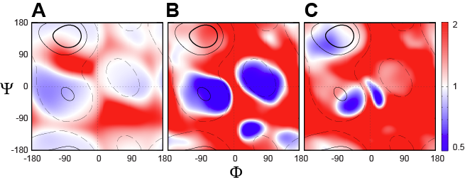
Figure S1. Comparison of backbone φ/ψ torsion angle distributions for different coil libraries. To compare the newly generated coil library in this work and the coil library generated by using the criteria developed for (A) MERA method,² (B) Fitzkee coil library,³ and (C) Coil4 library,⁴ the distribution of the ratio of the normalized residue density, d(φ,ψ)/Σd(φ,ψ) (see Fig. 1 legend), is plotted on a scale from blue (ratio of 0.5) to red (2.0). Regions with normalized residue density d(φ,ψ)/d_{max} above thresholds of 60%, 30% and 3%, respectively, in the newly generated coil library are marked by dark solid, light solid and dashed lines, respectively.
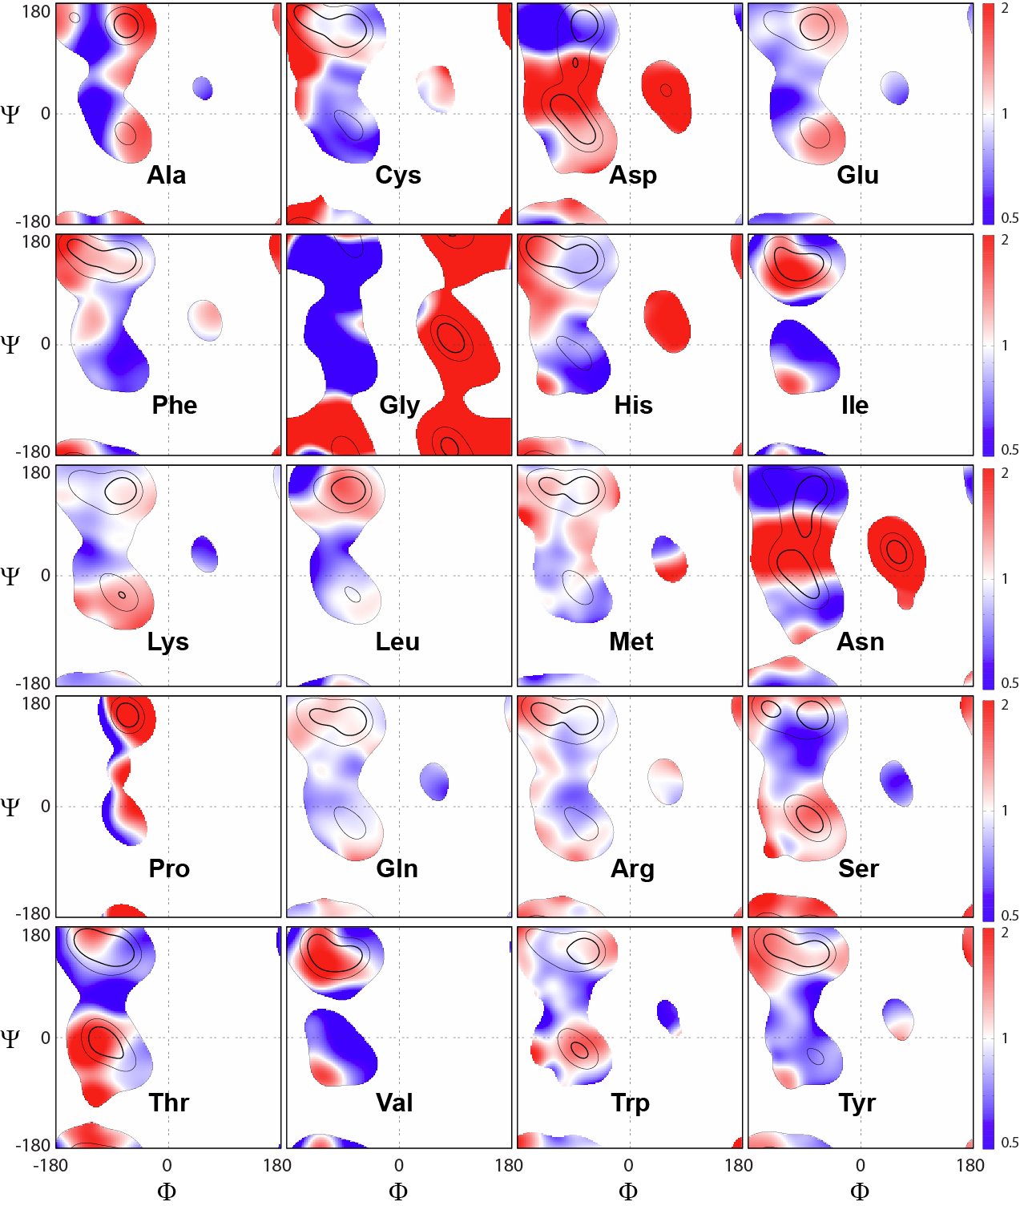
Figure S2. Residue-specific backbone φ/ψ torsion angle distributions as observed for the newly generated coil library. For each residue type X_{i}, the normalized residue density ratio d(φ,ψ)/Σd(φ,ψ) (see Fig. 1 for definition) between subset {X_{i}} and all data in the coil library (except for Xaa-Pro) is displayed on a color scale ranging from blue (ratio of 0.5) to red (2.0). Regions with a residue density d(φ,ψ)/d_{max} above thresholds of 60%, 30% and 3%, respectively, in the {X_{i}} subset are marked by dark solid, light solid and dashed lines, respectively. Regions with a residue density d(φ,ψ)/d_{max} below 3% in the {X_{i}} subset are not plotted.
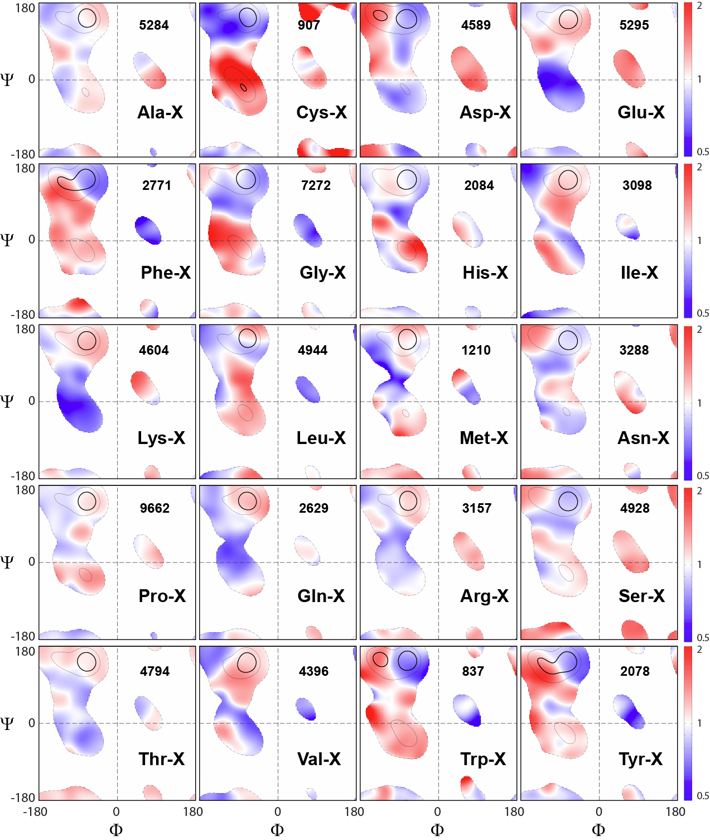
Figure S3. Same as Figure S2, but evaluating the impact of the preceding residue on the backbone φ/ψ torsion angle distributions as observed in the newly generated coil library. For each residue type Z, the normalized residue density ratio d(φ,ψ)/Σd(φ,ψ) (see Fig. 1 for the definition) of its following residue X is plotted, where the denominator extends over all residues X in the coil library except Gly, Pro and Xaa-Pro.

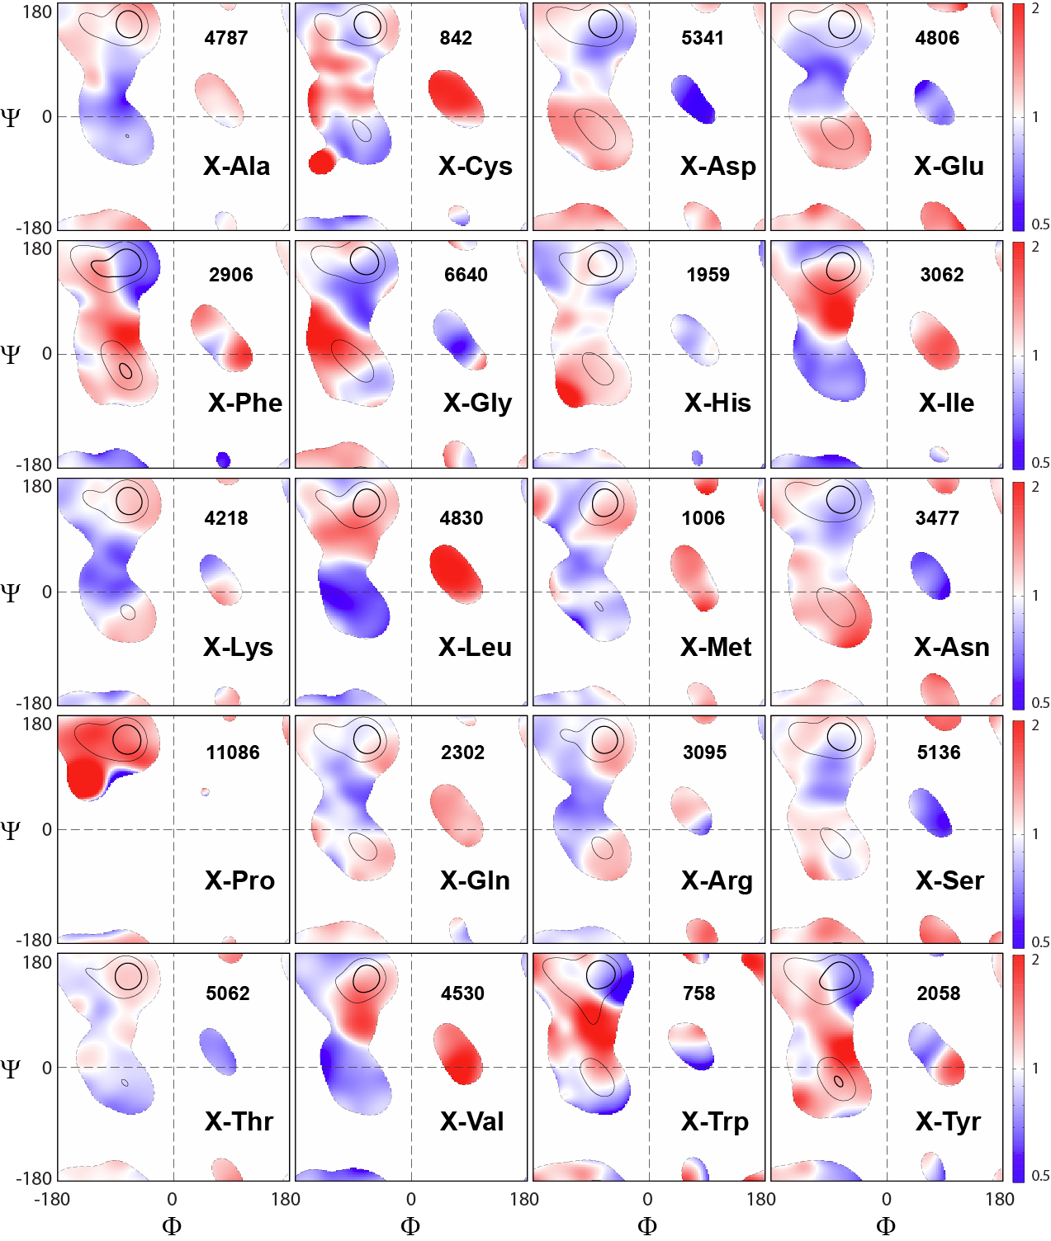
Figure S4. Same as Figure S3, but evaluating the impact of the following residue on the backbone φ/ψ torsion angle distributions. For each residue type Z, the normalized residue density ratio d(φ,ψ)/Σd(φ,ψ) (see Fig. 1 for the definition) of its preceding residue X is plotted, where the denominator extends over all residues X in the coil library except Gly, Pro and Xaa-Pro.

References

1. Kjaergaard M, Poulsen FM (2011) Sequence correction of random coil chemical shifts: correlation between neighbor correction factors and changes in the Ramachandran distribution. J. Biomol. NMR 50:157-165
2. Mantsyzov AB, Shen Y, Lee JH, Hummer G, Bax A (2015) MERA: A webserver for evaluating backbone torsion angle distributions in dynamic and disordered proteins from NMR data. J. Biomol. NMR 63:85-95
3. Fitzkee NC, Fleming PJ, Rose GD (2005) The protein coil library: A structural database of nonhelix, nonstrand fragments derived from the PDB. Proteins 58:852-854
4. Zhou CY, Jiang F, Wu YD (2015) Residue-Specific Force Field Based on Protein Coil Library. RSFF2: Modification of AMBER ff99SB. J. Phys. Chem. B 119:1035-1047
5. Smith LJ, Fiebig KM, Schwalbe H, Dobson CM (1996) The concept of a random coil - Residual structure in peptides and denatured proteins. Folding & Design 1:R95-R106
6. Serrano L (1995) Comparison between the Phi Distribution of the Amino-Acids in the Protein Database and Nmr Data Indicates That Amino-Acids Have Various Phi Propensities in the Random Coil Conformation. J. Mol. Biol. 254:322-333
7. Shi ZS, Chen K, Liu ZG, Ng A, Bracken WC, Kallenbach NR (2005) Polyproline II propensities from GGXGG peptides reveal an anticorrelation with beta-sheet scales. Proc. Natl. Acad. Sci. U. S. A. 102:17964-17968

