Supplementary Material

Superoxide is the critical driver of DOPAL autoxidation, lysyl adduct formation, and crosslinking of α-synuclein

Jon W. Werner-Allenª, Rodney L. Levine^{b,*}, and Ad Bax^{a,*}

ªLaboratory of Chemical Physics, National Institute of Diabetes and Digestive and Kidney Diseases, and
^{b}Laboratory of Biochemistry, National Heart, Lung, and Blood Institute, National Institutes of Health, Bethesda, Maryland 20892, United States
*E-mail: rlevine@nih.gov, bax@nih.gov
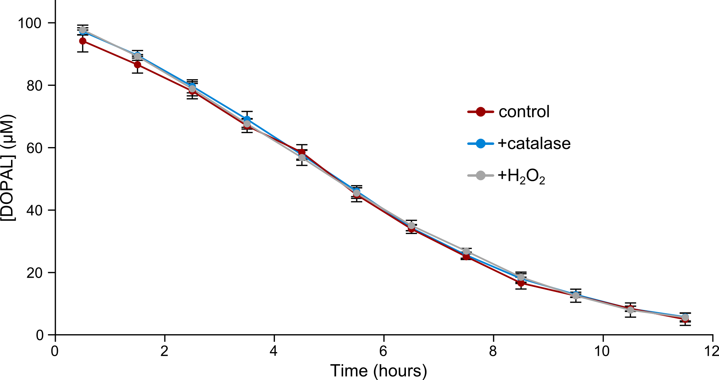
Figure S1. Hydrogen peroxide does not contribute significantly to DOPAL autoxidation. 100 μM DOPAL was incubated in PBS at 37 °C and followed in 1D ¹H NMR spectra, and concentrations were quantified using the integrated intensities of the DOPAL alpha proton signal. The autoxidation was very similar for samples with DOPAL alone (red), with 50 nM catalase (blue), or with 100 μM hydrogen peroxide (gray).
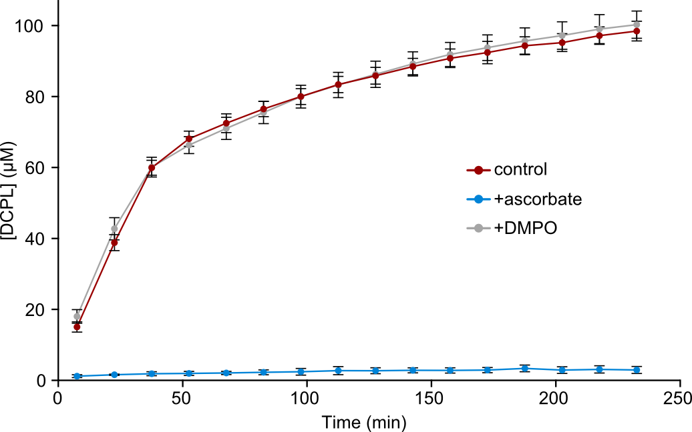
Figure S2. Effect of radical scavengers on dicatechol pyrrole lysine formation. The production of DCPL was monitored using the integrated signal intensities in 1D ¹H NMR spectra for reactions between Ac-Lys and DOPAL alone (red), with 10 mM ascorbate (blue), and with 10 mM 5,5-dimethyl-1-pyrroline N-oxide (gray). Concentrations are averaged over three independent replicates and error bars represent standard deviations. The contrasting abilities of ascorbate and DMPO to inhibit DCPL formation can be attributed to the ~10⁷ difference in their rate constants toward superoxide.
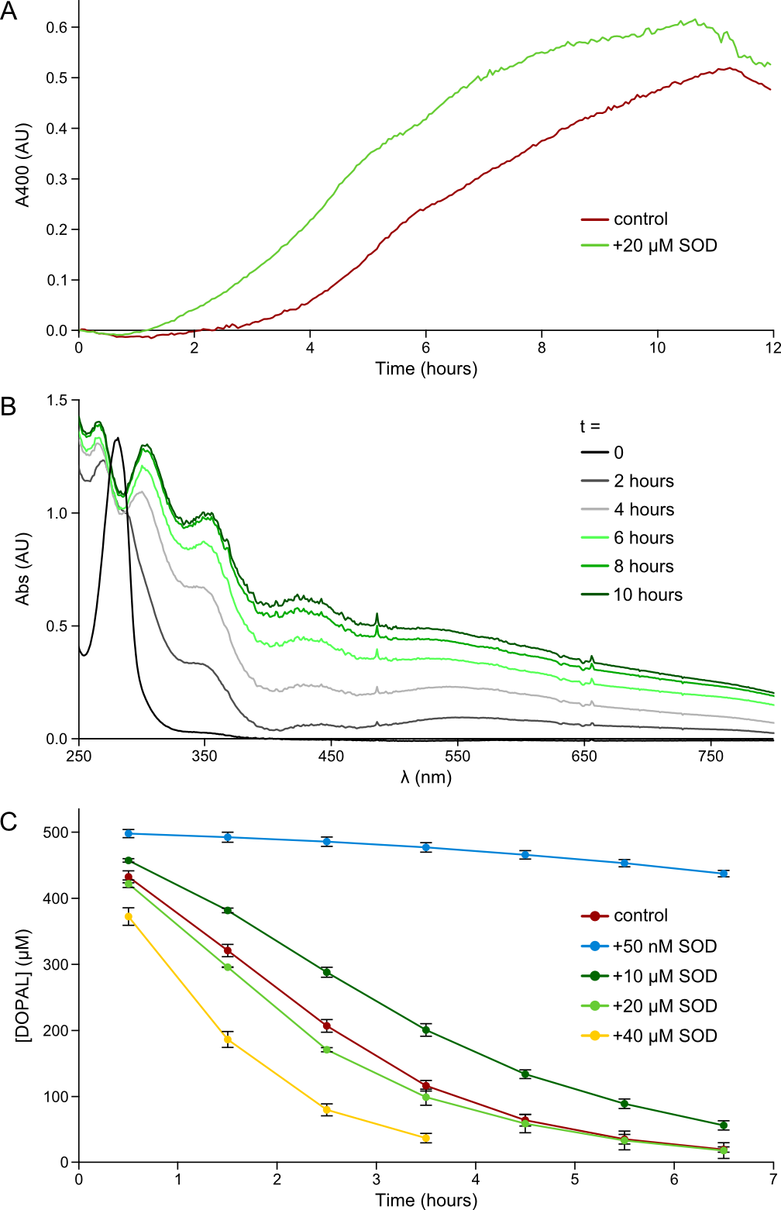
Figure S3. High concentrations of superoxide dismutase accelerate DOPAL autoxidation. The autoxidation of 500 μM DOPAL was followed at 37 °C in 50 mM sodium phosphate buffer at pH 7.8 with 100 μM DTPA. (A) Reactions with and without 20 μM SOD were monitored by absorbance at 400 nm. (B) Individual spectra from the reaction with 20 M SOD in (A) are shown. Note the large increase in absorbance at longer wavelengths due to light scattering, which could result from polymerization of oxidized DOPAL products or oligomerization of the SOD by DOPAL crosslinking. (C) Autoxidation was also followed by 1D ¹H NMR with different concentrations of SOD. The native autoxidation rate of DOPAL is faster compared to the decay in PBS due to the higher pH of these samples (7.8 versus 7.4). At the SOD concentration used in this study (50 nM), DOPAL autoxidation is dramatically inhibited. At much higher concentrations (10-40 μM), DOPAL decay accelerates, eventually exceeding the rate of autoxidation. Further purification of our SOD stocks by spin desalting columns had no effect on the stimulation of DOPAL oxidation (data not shown), eliminating the possibility of interference by a small molecule contaminant. The accelerated oxidation may result from an unknown secondary activity of SOD that outcompetes superoxide dismutation at high concentrations of the enzyme or from an enzymatic contaminant of the SOD preparation.

